Load Balanced Architecture with Advanced Request Routing
This lab guide creates a simple website, hosted on EC2, behind an Application Load Balancer. Host-based and path-based routing rules will then be configured to route based on information in the host header or URL path.
Host-based routing allows you to route to multiple domains on a single load balancer by routing to a different set of EC2 instances or containers based on information in the host header.
Path-based routing is also referred to as URL-based routing. The Application load Balancer will forward the requests to the specific targets based on the rules configured on the load balancer. We will be doing this first.

Requirements (Prerequisites)
- AWS Free Tier Account
- Basic Exposure to the AWS Console and completion of prior days learning
- Follow the steps in Section 8 of the course to register your own domain name in Route 53

Resources
Download the “advanced-request-routing-code.zip” file.

Exercise Overview
Exercise 1 – Create the Red and Blue EC2 instances
Exercise 2 – Enable Path-based Routing
Exercise 3 – Enable Host-based Routing
Exercise 4 – Clean up your resources

Exercise 1 - Create the Red and Blue EC2 instances
Task 1 - Create the S3 Bucket and Upload the code

The first step is to upload the code we will use to create the websites into an S3 bucket.
- Go to the S3 console and click ‘Create Bucket’.
- We will call out bucket ‘arr-bucket-123456’ with the numbers at the end being random to make the bucket globally unique. Take a note of the bucket name as we will be referring to it again shortly.
- Scroll down and click ‘Create Bucket’.
- Locate the files you have downloaded as part of the course and select all files except the user data files and bucket-permissions file and upload them to the bucket.

Task 2 - Create your Security Group

The second step is to pre-emptively create the Security Group for your EC2 instances.
- Go to the EC2 console, scroll down to the ‘Security Group’ column under ‘Network Security’. Click ‘Create Security Group’. We will call it ‘WebsiteSG’. Populate the description field with ‘WebsiteSG’ also.
- Under inbound rules - simply add one rule:
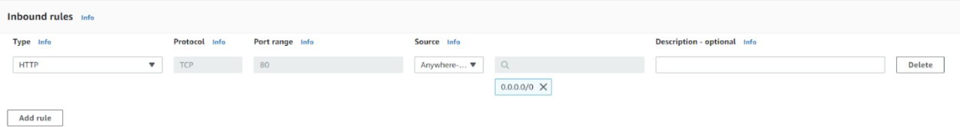

- This is an HTTP rule, with an ‘Anywhere IPv4’ source. Create the Security Group.

Task 3 - Create an IAM Role for EC2 and Launch the Red Instance
- Head over to the IAM console and select ‘Policies’.
- Click ‘Create policy’ and move to the JSON section. Copy and paste the code from the bucket-permissions. Json file into the code window, replacing ‘YOUR-BUCKET-ARN’ with the ARN of the bucket you have just created.
- Click review policy, and Create policy, call it ‘S3-ARR-Policy’.
- Click ‘Roles’ and select ‘Create role’.
- Under common use cases, select ‘EC2’ and click next.
- For permissions policies attach the ‘S3-ARR-Policy’.
- Click next and call it ‘S3-ARR-Role’.

We will now launch the ‘Red’ EC2 instance and check to see if it has successfully retrieved the code from S3.
- Head over to the EC2 console and select ‘Launch Instance’.
- Call your first instance ‘Red’.
- Select the AMI, and under ‘Instance type’, select ‘t2.micro’.
- For ‘Key pair’, leave the default setting ‘Proceed without a key pair’.
- Under ‘Network settings’ select the security group you created earlier and choose the
subnet us-east-1a.
- Expand ‘Advanced Details' and under ‘IAM instance profile’ select the ‘S3-ARR-Role’role created before.
- Next, copy the user data from the ‘user-data-red’ file into the ‘User data’ field. It should look like the image below. You will also need to edit the name ‘YOUR-BUCKET-NAME’ in the user data to the name of your S3 bucket.
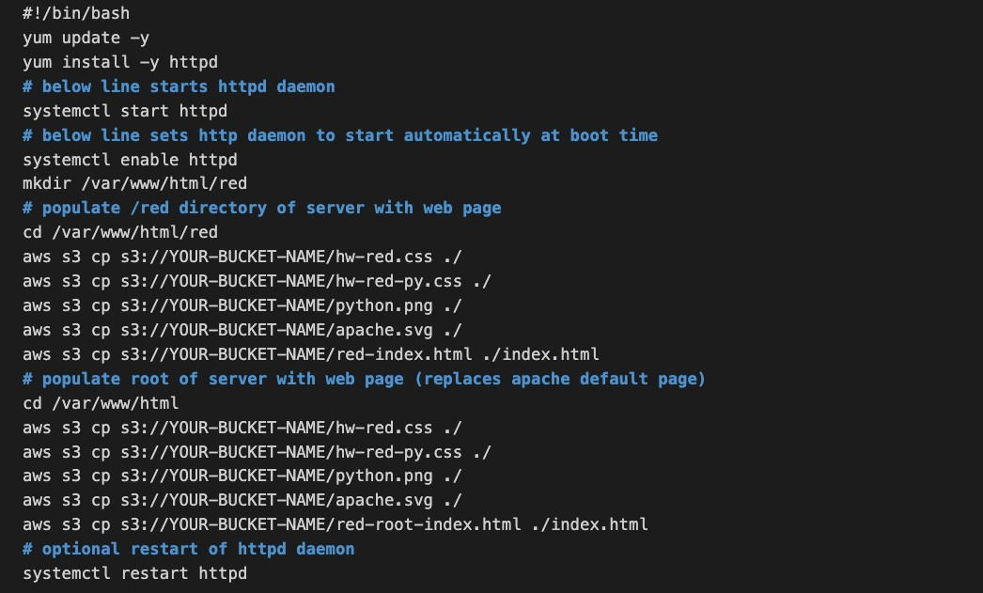
- Create the instance.
- Follow the exact same steps to create the Blue instance with the blue user data (user-data- blue) and select subnet us-east-1b.

You should then be able to get the public IP address from either instance to view the web pages created on each EC2 instance. You will need to add /blue and /red to the appropriate instance to return the custom web page.

Exercise 2 – Enable Path-based Routing
With path-based routing we will enter a path to our URL and the load balancer will route the request to the appropriate target group based on the rules we create.

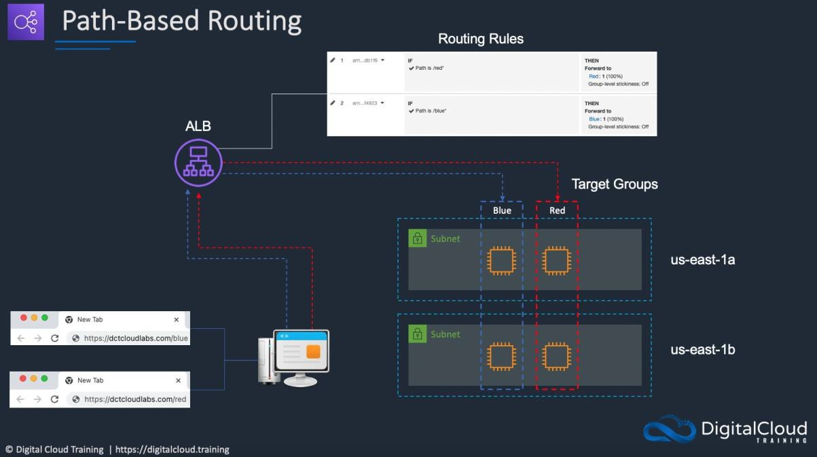

Task 1 – Create your target groups

The first step is to set up the target groups; you need at least 2 target groups to configure Path-based routing.
- Click on Target Groups under Load balancing.
- Click ‘Create target group.’
- Set up 2 target groups, one is called ‘Red’ which will contain the red targets, and the other is called ‘Blue’ and will contain the blue targets.
- Leave all the defaults, except changing the target group name to ‘Red’ / ‘Blue’ and change the health check to:
  - For Red: /red/index.html
  - For Blue: /blue/index.html
- Register the correct instance i.e., Red and be sure to click ‘include as pending below’.
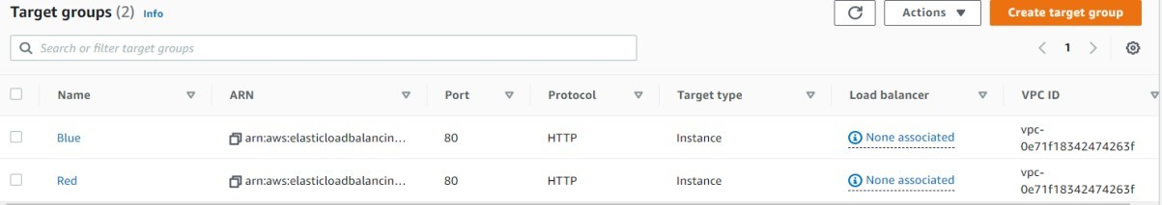

Task 2 – Create your Application Load Balancer
Next step is to create the Application Load Balancer.
- On the left-hand side of the EC2 console you will find the link for Load Balancers.
- Click ‘Create Load Balancer’ and choose the ‘Application Load Balancer’.
- Call the load balancer ‘LabLoadBalancer’ and leave the Scheme as Internet Facing.
- Select both of us-east-1a and us-east-1b for the subnet mappings. This will allow routing of traffic across the instances in different AZs.
- Choose the same Security Group as earlier (WebsiteSG).
- Choose the listener and routing as per the image below; we will configure the routing rules later.
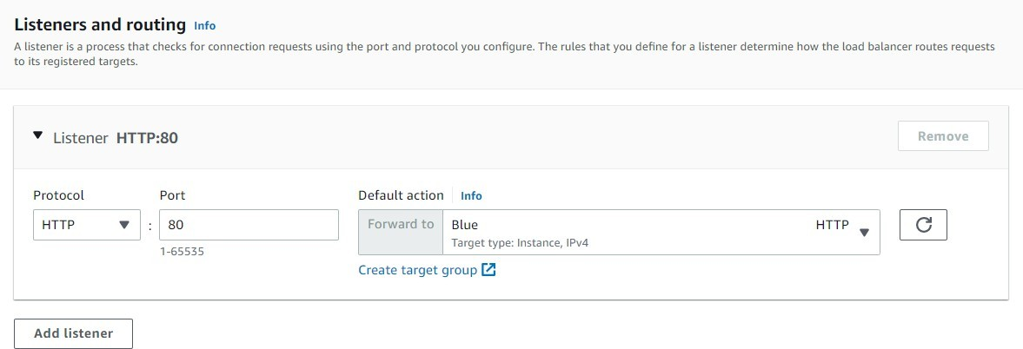

- Click Create load balancer and wait a few minutes for it to turn from ‘Provisioning’ to ‘Active’.
- Once active, under ‘Listeners and rules’, select the checkbox for your first listener. Then, under the ‘Manage Rules’ menu, click ‘Add rule’.
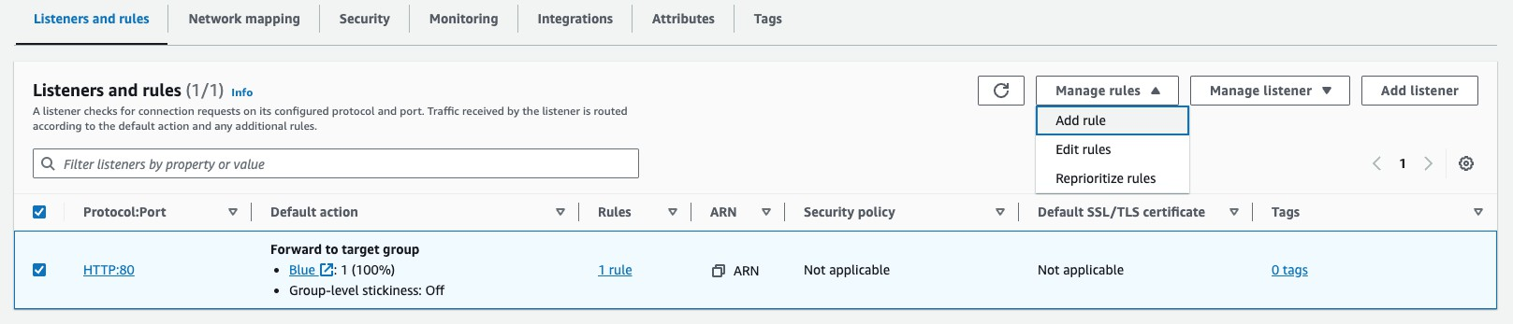

- Configure as follows:
  - Name and tags – ignore and click next.
  - Conditions – click ‘Add condition’ and select ‘Path’ from the dropdown menu and enter “/red*” for the path.
  - Actions – Forward to the ‘Red’ target group.
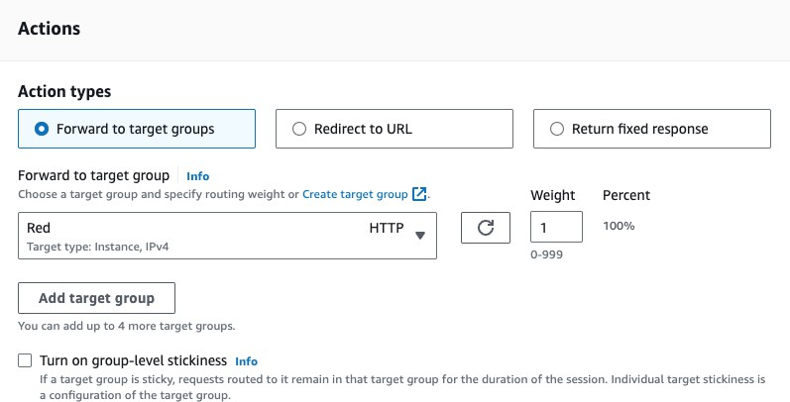
  - Priority – set to 1.

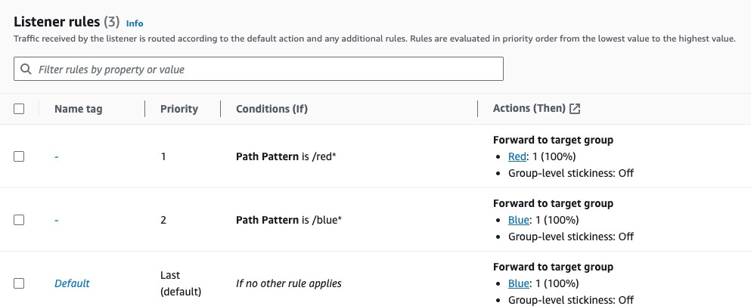
- Repeat the above creating a rule for the blue target group. The path should be “/blue*’ and priority can be 2. The listener rules should now look like this:
- We can then test the load balancer’s path-based routing by copying the DNS name from the Application Load Balancer and append either /blue or /red on the URL and see what happens. You should see the different colored custom web pages we added to our instances.

Exercise 3 – Enable Host-based Routing
With host-based routing we will enter a subdomain to the domain name and the load balancer will route the request to the appropriate target group based on the rules we create.
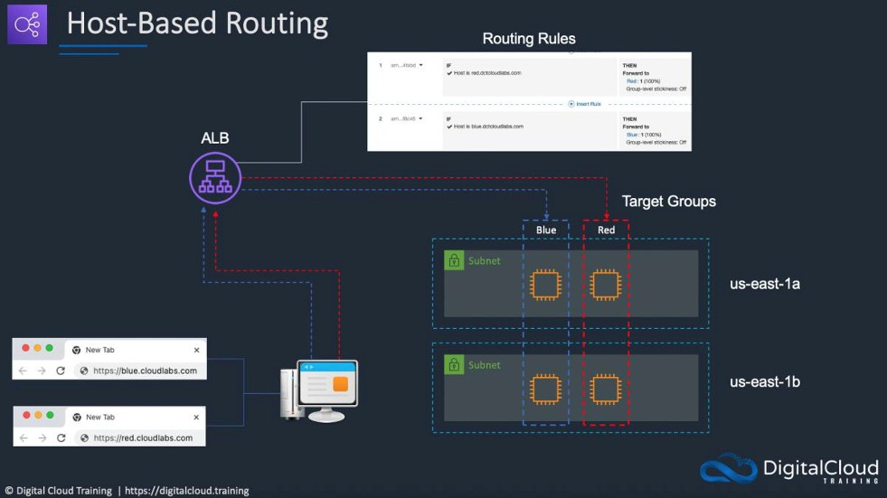

Task 1 – Edit host-based forwarding rules

The first step is to set up the forwarding rules. You need at least 2 target groups to configure host-based routing.
- Navigate back to the listener.
- Click on ‘Edit rules’ under the ‘Manage rules’ menu.
- Select and delete both path-based rules.
- Add a new rule to the listener and configure as follows:
  - Conditions – add a host header condition and for your value, enter your domain name with “red” as the subdomain, e.g. “red.yourdomainname.com” (swap the domain name for your registered domain).
  - Actions – Forward to the ‘Red’ target group.
  - Priority – set to 1.
- Repeat the above creating a rule for the blue target group. The host header value should be “blue.yourdomainname.com” (swap the domain name for your registered domain) and priority can be set to 2.
- The rules should look something like this:
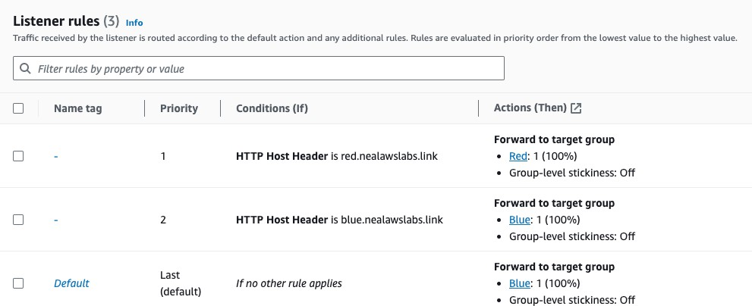

Task 2 – Configure Records in Route 53

In this task we need to create the relevant subdomain DNS records in Amazon Route 53 and configure the load balancer as the target.
- Open Route 53 dashboard from the management console, find your public domain name under hosted zones. Click on it and select ‘Create Record.’
- Enter various details for this record:
  - subdomain: blue or red.
  - Record type: Select A type here.
  - Value/Route traffic to:
  - Select 'Alias to Application and Classic Load Balancer' Select region N.Virginia.
  - Select the target load balancer we made earlier.

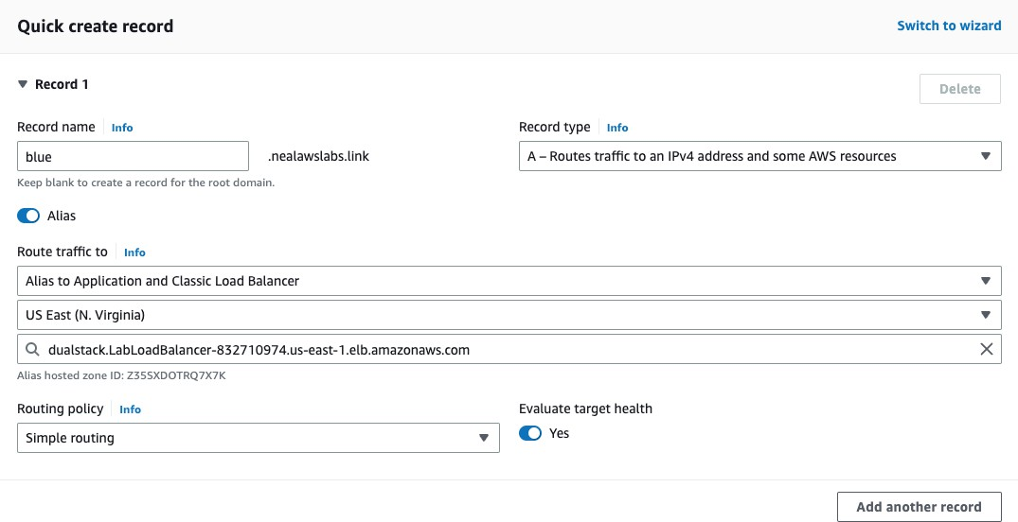
- Make sure you repeat the above steps to ensure you have one DNS record for each of the blue and red subdomains.
- Create an additional record for the apex/naked domain name that points to the ALB.
- The DNS records should look something like this:
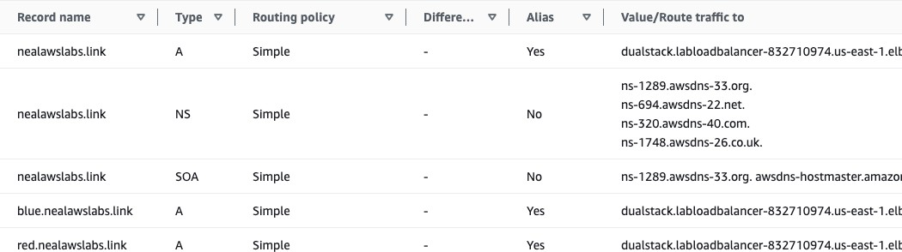

- To check if everything is working as expected, open a web browser, and use the following format for the URL:

red.yourdomainname.com

blue.yourdomainname.com

You should see the webpages of the relevant EC2 instance. You can also append the paths to the application page.

Exercise 4 – Clean up your resources Task 1 – Delete your resources

You can now delete the resources you created:
  - Application Load Balancer (chargeable).
  - Target groups (not chargeable).
  - Security Group (not chargeable).
  - Amazon EC2 Instances (chargeable).
  - Amazon S3 bucket (chargeable).
  - Amazon Route 53 Alias records (not chargeable).

